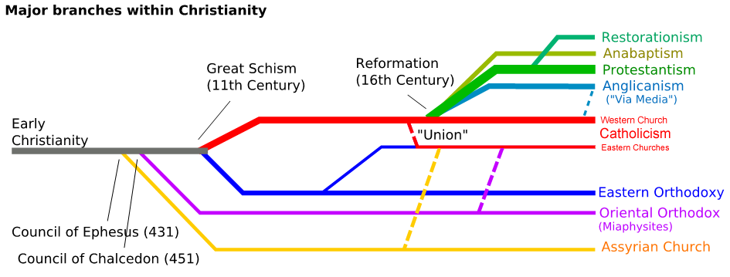

Choose one of the branches of Christianity (Not Catholicism the red one) and complete the following:

My choice is:

|  |
| --- |
| Three things that they believe or do that is different from Catholicism: |
|  |
|  |
|  |
| Three things they do or believe that is the same as Catholicism: |
|  |
|  |
|  |

|  |  |
| --- | --- |
| Find a picture of a place of worship from your branch & Catholicism and put them below. | |
| Your Choice is: | Catholicism: |
|  |  |
| Find a prayer from your branch & Catholicism and write them below. | |
| Your Choice is: | Catholicism: |
|  |  |

NCRS 2017