Some Reformation Characters: Who are they?
Find out 3 things about each of these people.
Martin Luther  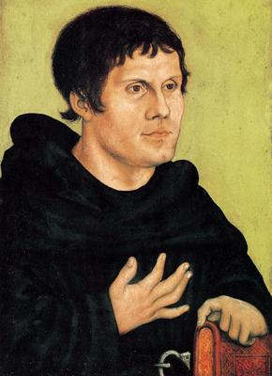 | I know:
I know: | Jean (John) Calvin  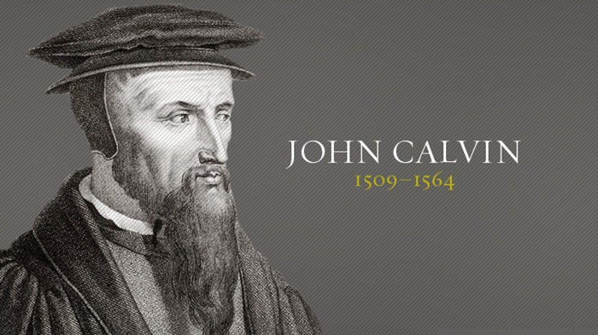

King Henry VIII  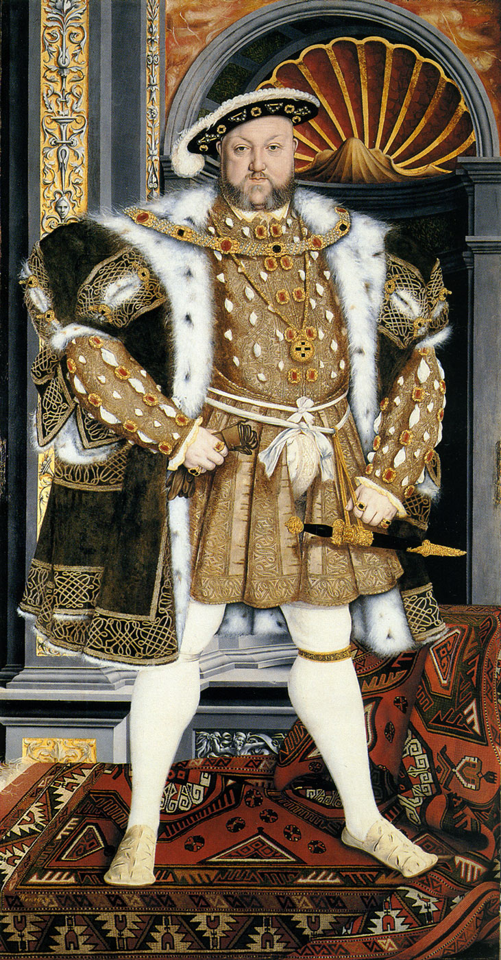 | I know:
I know: | 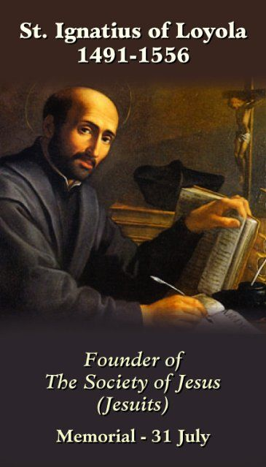

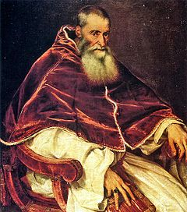  Pope Paul III | I know
I know: | Catherine de Medici  1519 -1589  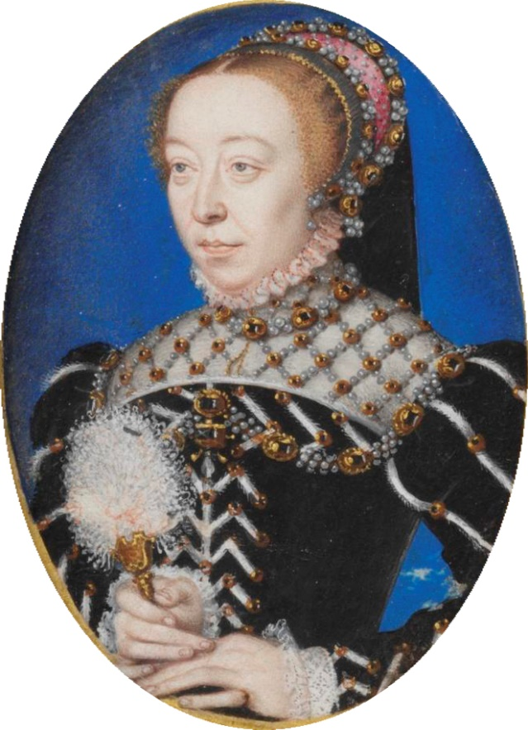

NCRS 2017

