Reflection on Care for our Common Home
We gather today as the people of God, to give praise and glory to the God of love and kindness. We come, as people in need of healing. As blessed people, called and gifted by our God to reach out in service to those in need.  Jesus, you love us and call us children of God  Lord have mercy  Jesus, you invite us to care for the poor and to welcome all people.  Christ have mercy.  Jesus, you give us gifts to share so that all may have enough.  Lord have mercy. | 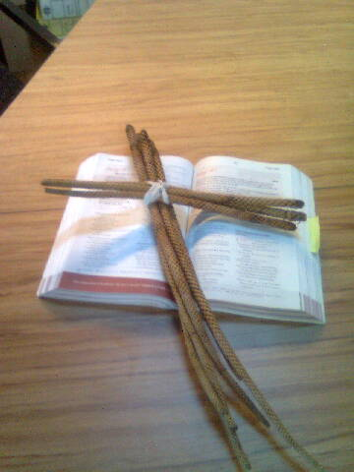

A reading from the Gospel according to Matthew (adapted Mt 25:31 - 46)
God will say to the people on the right: “Come, you are all blessed, come and possess the Kingdom which has been prepared for you since the creation of the world.
For I was hungry and you cared enough to feed me.
I was thirsty and you gave me something to drink.
I was a stranger, someone different from you and yet you welcomed me a friend.
I was in need of clothing and you gave me more than enough.
I was sick and you took care of me.
I was alone in prison and you took time to visit me and comfort me.”
Then God will say to those on the left: “Away from me, away from me forever!
For I was hungry and you turned away from me.
I was thirsty and you ignored me.
I was a stranger and you refused to accept me.
I was cold and you did not care.
I was sick and you were in too much of a hurry to help me.
I was frightened, alone and without friends and you abandoned me.”
And God said: “Remember this: whenever you do something good and kind to one of my people, I count it as being done to me.”

The Gospel of the Lord: Praise be to you Lord Jesus Christ.
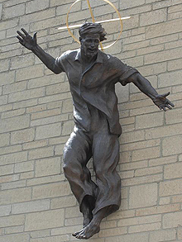 | Excerpts from Laudato si’  Pope Francis 2015
Catholic Church Uckfield Sussex used with permission
Intercessions:

What we believe of our Creator, we believe of the Word and of the Holy Spirit. Our God is One. We pray:
All glory & praise to you!

Loving God, grant wisdom & integrity to all who lead our Church & the nations of the world. We pray:
All glory & praise to you!

Loving God bless our efforts to grow in the way of your commandments. We pray:
All glory & praise to you!

Loving God help us to be worthy of the promises of Christ. We pray:
All glory & praise to you!

Loving God give us the courage to let our relationships be loving, mature & just. We pray:
All glory & praise to you!

Loving God, may we live & love in your image & likeness. We pray:
All glory & praise to you!

Watch Prince Ea video Sorry

We pray together:

Holy God, Source of all Being, Eternal Word & Holy Spirit, you have created all things & you continue to call us to new life. Teach us to reverence in one another the gift of life that we share. Give us a hunger for your Word & let us walk in union with your Spirit all the days of our lives.
Amen.

What are you going to do?

