Tile puzzle on Laudato Si'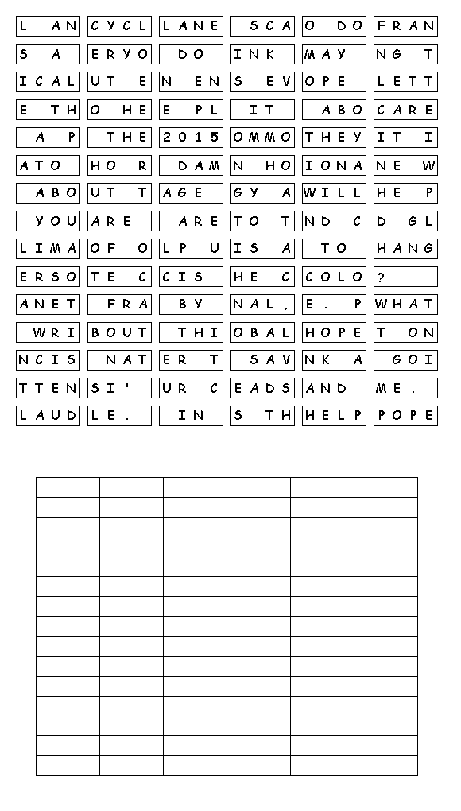

NCRS 2018

