**SRE Bridging Document – Introductory Sessions Information**

The following information is intended to help with running with Introductory Sessions for the Religious Education Bridging Document. There are three PowerPoints in total.

**Session 1** - What is the SREBD; Relationship with the UF RE Curriculum

Preperation

* Ask all participants to have an electronic copy of the SREBD on their devices so they can look at parts during the gathering.
* Provide copies, enough for at least one between two, of:
  + The Foreword and Vision Statement of the “[Understanding Faith](http://www.faithcentral.co.nz/wp-content/uploads/2016/10/UF-Curriculum-Statement-Final-Sept-2010.pdf) – Religious Education Curriculum Statement for Catholic Secondary Schools – Years 9-13 (revised 2010)”
    - It would be good to ask people to have downloaded a copy of this.
* Provide some large sheets of paper & pens for small groups to record thinking during the session.

**Session 2** - Delving Deeper. Catholic Schools; what is RE; & Spirituality

Preperation

* Ask all participants to have an electronic copy of the SREBD on their devices so they can look at parts during the gathering.

**Session 3** – Considering our learners, assessment & Applying Pedagogy

Preperation

* Ask all participants to have an electronic copy of the SREBD on their devices so they can look at parts during the gathering.
* There’s a bit of audio in the powerpoint so have some speakers set up.
  + Slide 8 is organised to run on the next mouse-click so you can still use a ‘clicker’ and won’t need a mouse.
  + If this doesn’t work the same story is available in the first 1.45 minutes of the YouTube clip - <https://www.youtube.com/watch?v=Wal3Fmi2vcI&t=4s>
* Have some copies of page 42 – Considering our learners – copied off, preferably blown up to A3, for school groups to use.
  + Pens as required.
* Have a white board, or large sheets to record the large group PMI feedback from the pedagogy session.

*Foreword from the Religious Education Curriculum Statement for Catholic Schools – Years 9-13 (revised 2010)*

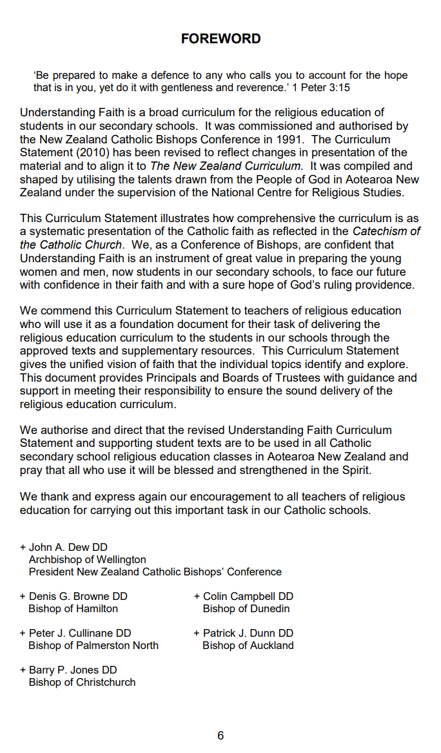

*Vision Statement from the Religious Education Curriculum Statement for Catholic Schools – Years 9-13 (revised 2010)*

